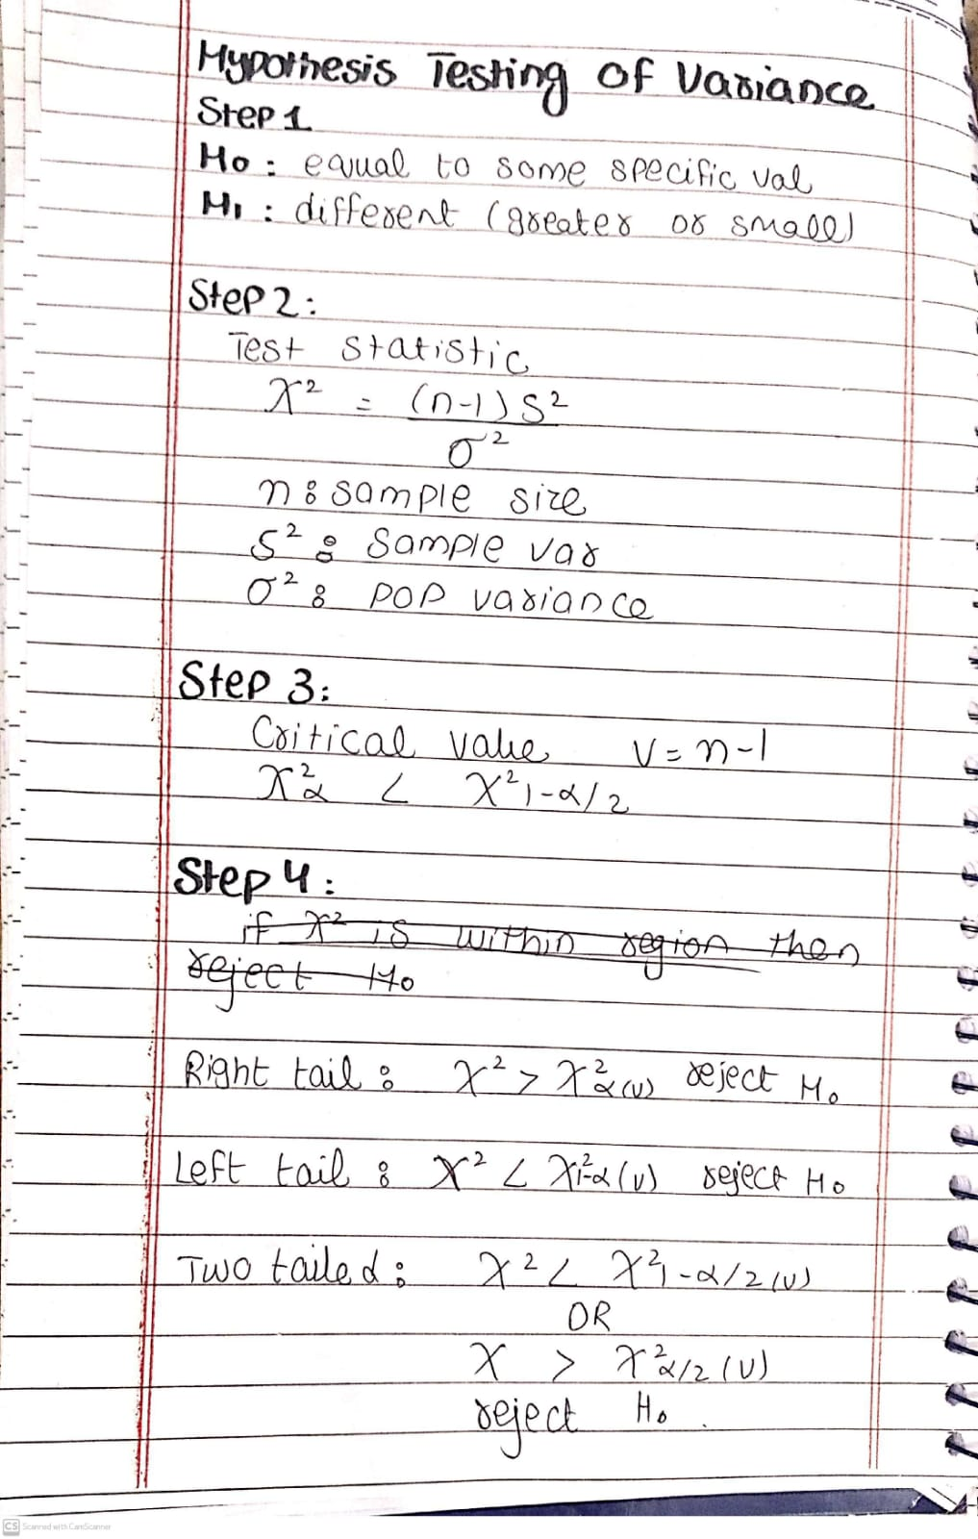

Practice question:
A factory produces metal rods with a standard deviation of 3 mm in their lengths. A quality control analyst wants to test if the population variance has changed. A random sample of 15 rods is taken, and the sample variance is found to be 10 mm². At a 5% significance level, test whether the population variance is still 9 mm² (σ² = 9) using the chi-square test.
- State the null and alternative hypotheses.
- Determine the test statistic.
- Find the critical value(s) or p-value.
- Conclude whether the population variance has changed.
